### ****Instagram ER Model****

**Entities and Attributes**

1. **User**
   * **UserID** (Primary Key)
   * **Username**
   * **Email**
   * **Password**
   * **DateJoined**
   * **Relationships**:
     + A user can create multiple **Posts** (One-to-Many relationship between User and Post).
     + A user can make multiple **Comments** (One-to-Many relationship between User and Comment).
     + A user can like multiple **Posts** (One-to-Many relationship between User and Like).
     + A user can follow multiple users (Many-to-Many relationship with Follow).
     + A user can send multiple **DirectMessages** (One-to-Many relationship between User and DirectMessage).
     + A user can create multiple **Tags** (One-to-Many relationship between User and Tag).
     + A user can post multiple **Stories** (One-to-Many relationship between User and Story).
2. **Post**
   * **PostID** (Primary Key)
   * **Caption**
   * **DatePosted**
   * **UserID** (Foreign Key)
   * **Relationships**:
     + Each post can have multiple **Comments** (One-to-Many relationship between Post and Comment).
     + Each post can have multiple **Likes** (One-to-Many relationship between Post and Like).
     + Each post can be tagged with multiple **Tags** (Many-to-Many relationship between Post and Tag).
     + Each post belongs to a single **User**.
3. **Comment**
   * **CommentID** (Primary Key)
   * **Text**
   * **DatePosted**
   * **UserID** (Foreign Key)
   * **PostID** (Foreign Key)
   * **Relationships**:
     + Each comment is posted by a **User**.
     + Each comment is associated with a **Post**.
4. **Like**
   * **LikeID** (Primary Key)
   * **DateLiked**
   * **UserID** (Foreign Key)
   * **PostID** (Foreign Key)
   * **Relationships**:
     + Each like is made by a **User**.
     + Each like is associated with a **Post**.
5. **Follow**
   * **FollowerID** (Foreign Key)
   * **FollowedID** (Foreign Key)
   * **DateFollowed**
   * **Relationships**:
     + **FollowerID** refers to the user who follows.
     + **FollowedID** refers to the user being followed.
     + This is a **Many-to-Many** relationship between users (each user can follow many users, and each user can have many followers).
6. **DirectMessage**
   * **MessageID** (Primary Key)
   * **SenderID** (Foreign Key)
   * **ReceiverID** (Foreign Key)
   * **MessageText**
   * **DateSent**
   * **Relationships**:
     + Each direct message is sent by a **Sender** (User).
     + Each direct message is received by a **Receiver** (User).
7. **Story**
   * **StoryID** (Primary Key)
   * **StoryURL**
   * **DatePosted**
   * **UserID** (Foreign Key)
   * **Relationships**:
     + Each story is posted by a **User**.
8. **Tag**
   * **TagID** (Primary Key)
   * **TagName**
   * **UserID** (Foreign Key)
   * **Relationships**:
     + A **Tag** is created by a **User**.
     + A **Tag** can be used for multiple **Posts** (Many-to-Many relationship with Post).

**ER Diagram**

This ER diagram captures the core structure of Instagram, including its users, posts, interactions (comments, likes, follows), and additional features like stories and tags.

[**https://lucid.app/publicSegments/view/9ef13f62-c2d4-4925-b12a-1bba3744d31b/image.png**](https://lucid.app/publicSegments/view/9ef13f62-c2d4-4925-b12a-1bba3744d31b/image.png)

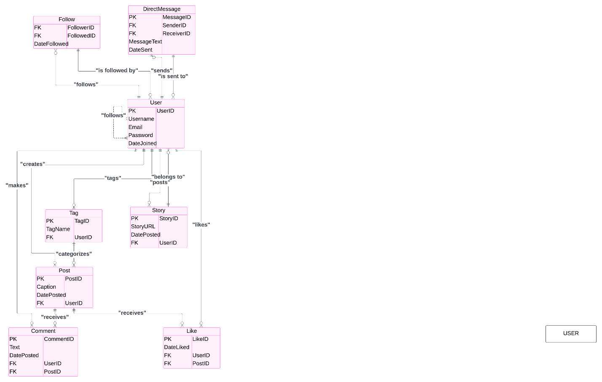

* User is the central entity in the Instagram model and is connected to other entities like Post, Comment, Like, Follow, Direct Message, Story, and Tag. Post is related to User (one-to-many) and Comment, Like, Tag (many-to-one). A Post can have many Likes and Comments, and many Tags.
* Comment links to both User and Post: one-to-many relationships.
* Like also links to both User and Post, meaning that a User can like many Posts, and each Post can have many Likes.
* Follow has a self-referencing relationship where a User can follow another User (one-to-many).
* Direct Message links Sender and Receiver as Users and is a many-to-one relationship.
* Story is a feature where each User can post multiple Stories.
* Tag can be associated with both User and Post: a Tag is created by a User and can be associated with many Posts.